SHT 31- Humidity and temperature sensor (0x44)

This sensor gives accurate readings of temperature and humidity levels of the surroundings.

Working: The sensor will check and record the temperature and humidity level. Then it will compare the recorded value with the range provided. If it is not within the range, an alert will be sent to the user to change the levels manually using air conditioning or humidifiers. Whereas if the values are in the range then there will be not alerts and sensor readings will be given.

My sensor: <https://learn.adafruit.com/adafruit-sht31-d-temperature-and-humidity-sensor-breakout>

UML Diagram:

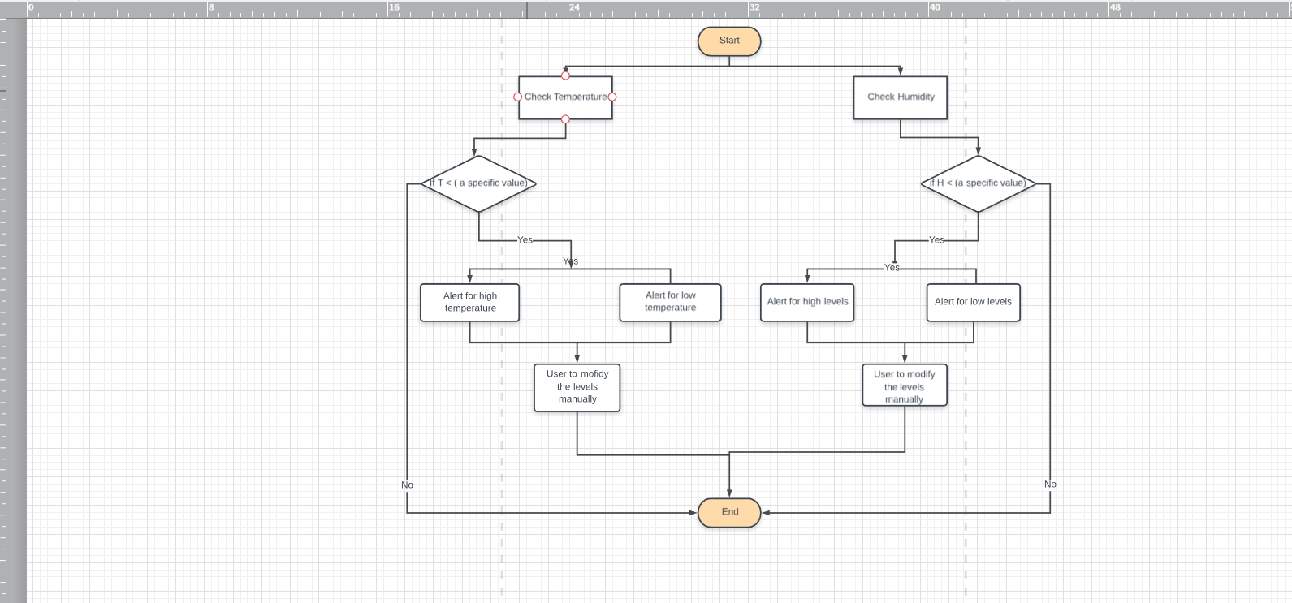

Tyler’s code:

/\*\*\ SHT31 Sensor

\*\ Reads the Temperature and humidity of the surroundings

\*\ null

\*\ numeric value

\*\ 10/16/2018

\*\ Tyler James Tanega - N01304001

\*/

setup {

power on;

printf("Starting SHT31 Sensor (Temperature & Humidity)\n");

sht31.begin(0x44);

}

loop{

float temp = 0;

float humid = 0;

sht31.readTemperature();

scan("%f", &temp);

sht31.readHumidity();

scan("%f", &humid);

do{

if(temp>=20 && humid>=50){

printf("Temp \*C = %f\n", temp);

printf("The temperature is high\n");

printf("Humidity = %f\n", humid);

printf("The humidity is high\n");

printf("Modify temperature & humidity levels manually if needed");

}else

if(temp>=20 && humid<=50) {

printf("Temperature \*C = %f\n", temp);

printf("The temperature is high\n");

printf("Humidity = %f\n", humid);

printf("The humidity is low\n");

printf("Modify temperature & humidity levels manually if needed");

}else

if(temp<=19 && humid>=50) {

printf("Temperature \*C = %f\n", temp);

printf("The temperature is low\n");

printf("Humidity = %f\n", humid);

printf("The humidity is high\n");

printf("Modify temperature & humidity levels manually if needed");

}else

if(temp<=19 && humid<=50) {

printf("Temperature \*C = %f\n", temp);

printf("The temperature is low\n");

printf("Humidity = %f\n", humid);

printf("The humidity is low\n");

printf("Modify temperature & humidity levels manually if needed");

}else{

system("pause");

return 0;

}

}while(temp>=-45 && temp<=125 && humid<=100 && humid>=100);

printf("The Sensor cannot read the temperature & humidity\n");

printf("Please check manual for the range that can be read");

system("pause");

return 0;

}